Construct a barometer
Materials and equipment
- glass jar
- balloon
- scissors
- strong rubber bands
- short drinking straw
- adhesive tape
- glue
- ruler

Safety
- Wear safety glasses.
- Make sure there are no signs of wear in the rubber band.
- Keep the rubber band away from your face, especially when you are stretching it.
Method
- Blow up the balloon carefully and then let the air out of it again. (This is to stretch the balloon.)  - Cut the balloon in half leaving the neck on one side only.  - Discard the piece with the neck on it.  - Take the remaining piece of the balloon and stretch it across the top of the jar. Keep it stretched firmly across and seal it down with the rubber band around the rim of the jar like a drum. To make an airtight seal, avoid gaps between the balloon and the jar.  - Flatten the drinking straw with your finger.  - Glue the straw onto the centre of the balloon lid.  - Leave about 5cm of straw overhanging the jar. The straw is your indicator ‘needle’.  - Support the ruler upright parallel to the side of the jar. The ruler can be taped to a wall so it does not fall over. The ruler’s ‘zero’ measurement should be at the bottom sitting on the floor or desk.  - The overhanging straw should be in line with the ruler.  - Record the height on the ruler that the end of the straw aligns with.  - Record the height on the ruler that the end of the straw aligns with at various times during the day/week. | 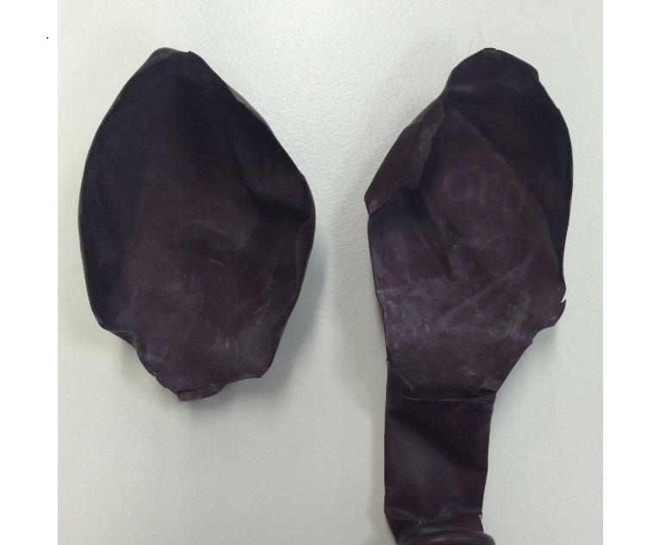  Keep Discard  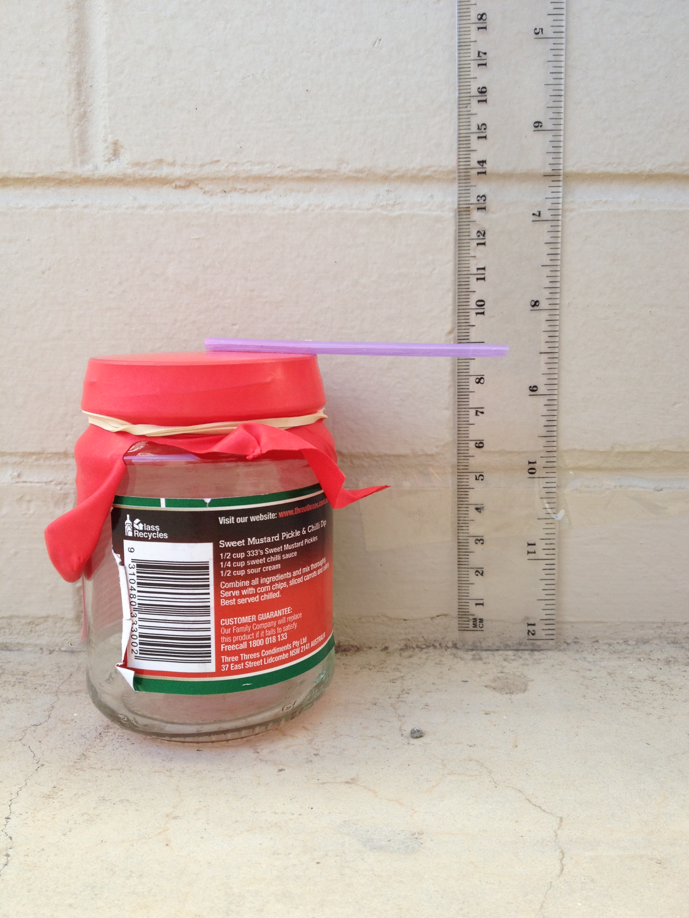

Conduct

Observations — What were your observations?

Record your observations of the movement of the straw.
Date/time of day | Reading (cm) | Movement from starting position
 | Starting position | _
Questions
- Explain how the device measures air pressure. Use your science knowledge.
- How well did the barometer work?
- How could you use this device to help inform you about the weather in your area?

